DAY 5:

WEEK 2 NEURAL NETWORKS AND DEEP LEARNING:

Logistic Regression is given by

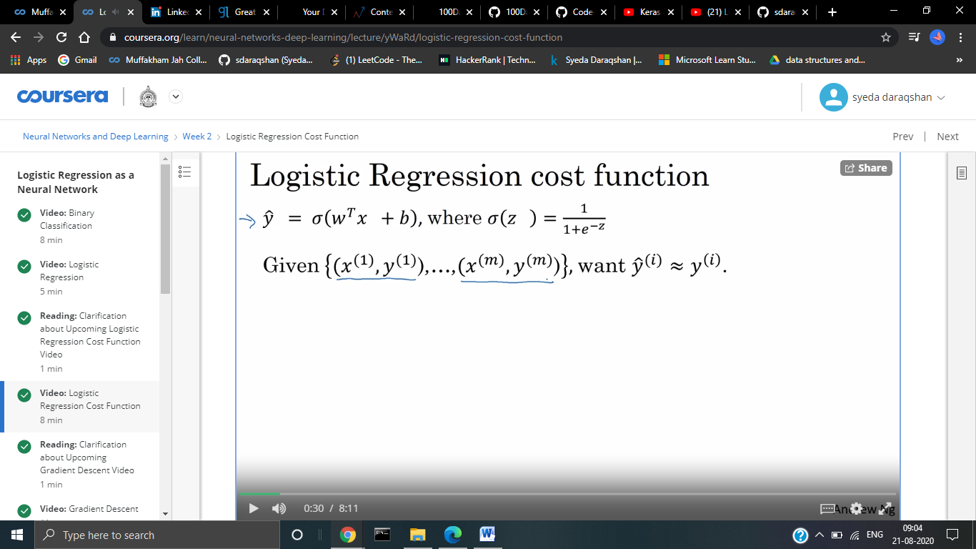

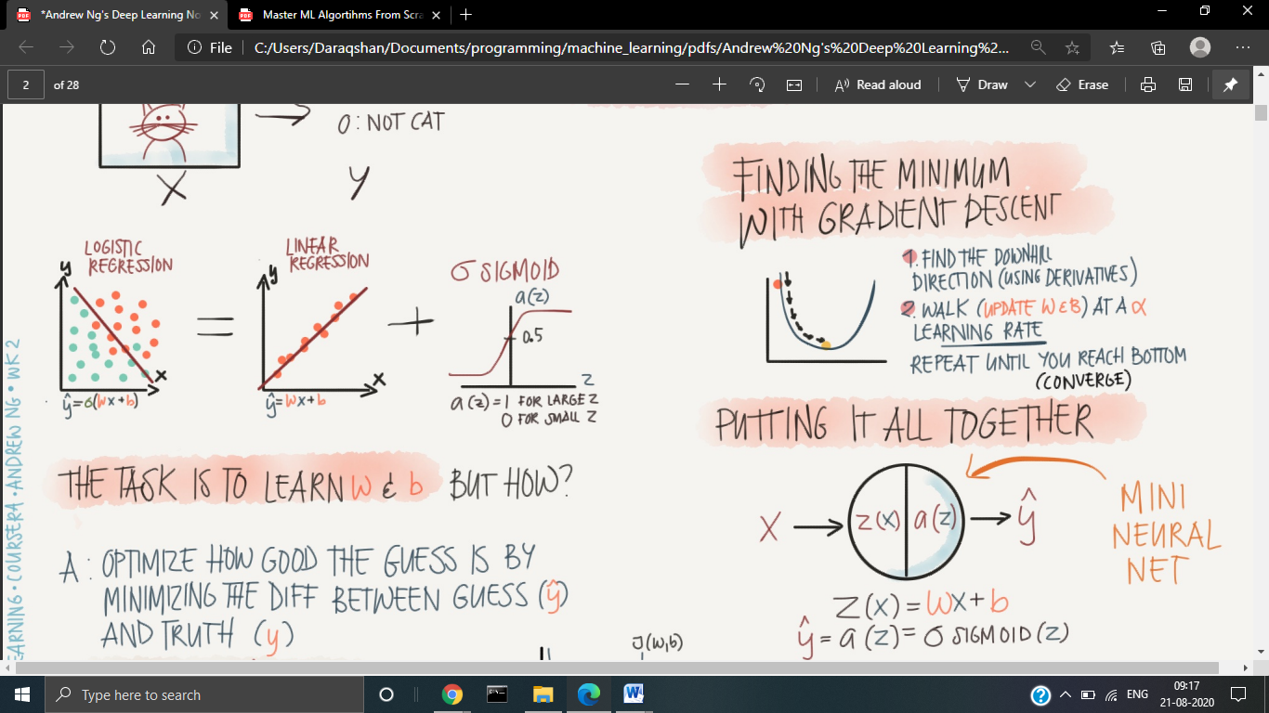

Loss Error Function is L(y^ ,y)

It computes error on a single training example.

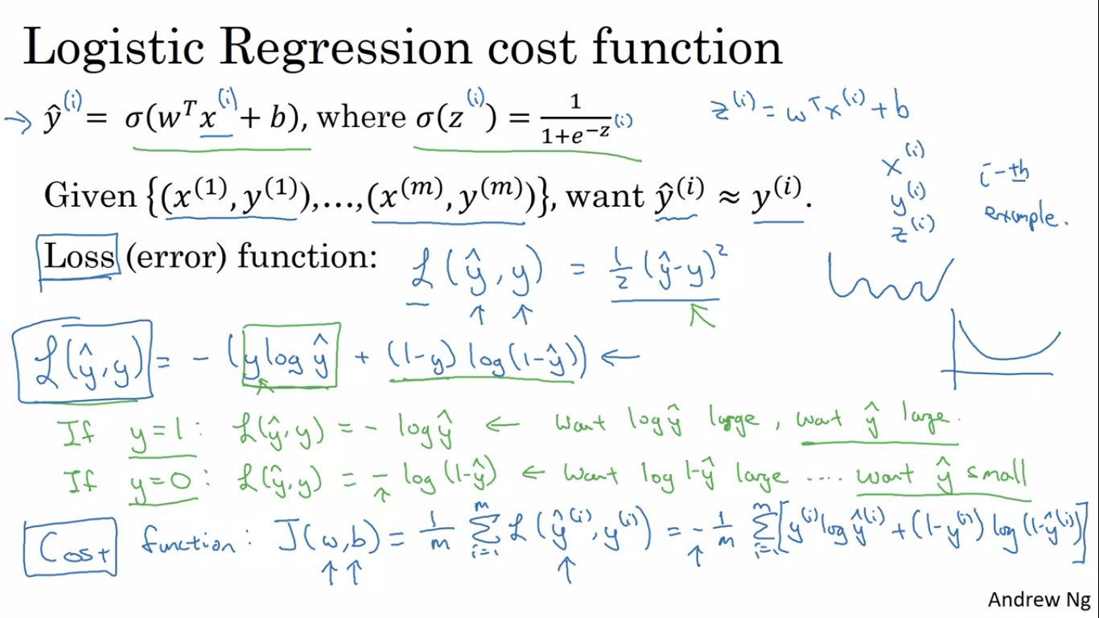

If y =1,then Loss= -log y^ => y^ should be large

If y=0,then Loss= -(log(1-y^)) => log(1-y^) should be large. => y^ should be small.

COST FUNCTION:

It computes error on the entire training set.

It is the average of the loss functions on the entire training set.



GRADIENT DESCENT:



W:= w-α dJ(w)/dw

α =Learning Rate

J(w)>0 then W is large and the value decreases.

J(w)<0 then W is small and the value decreases.

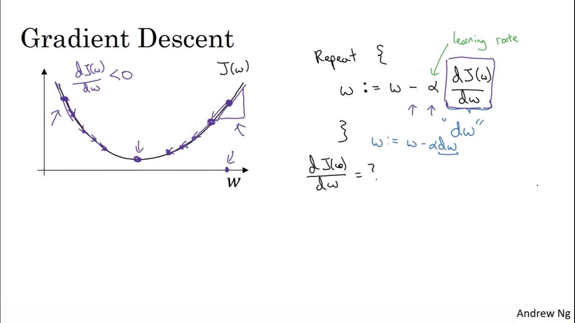

w=w-α dJ(w,b)/dw

b=b-α dJ(w,b)/dw

A convex funtion has one local optima.

FORWARD AND BACKWARD PROPAGATION:

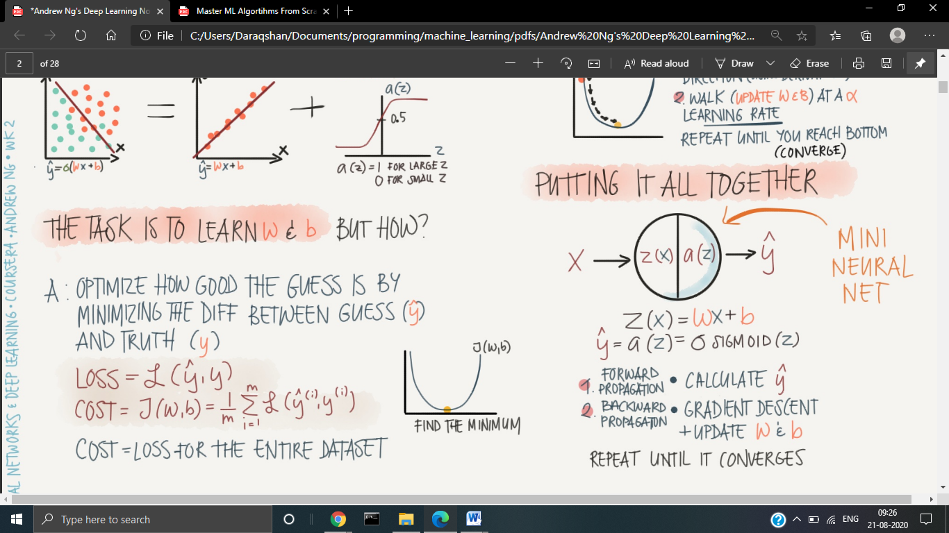

One step of backward propagation on a computational graph yields derivative of final output variable.

